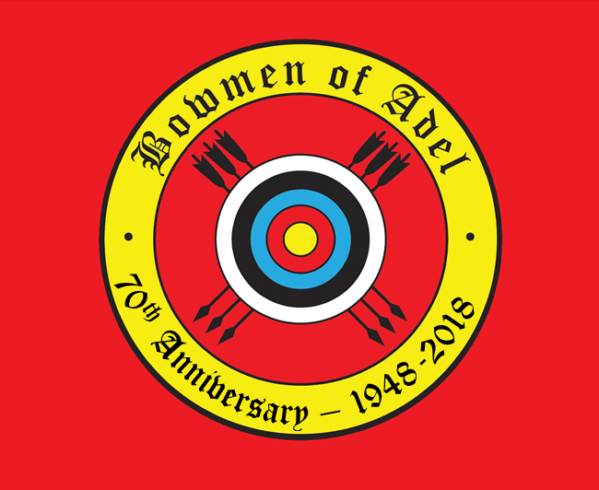  Privacy Notice  V1.0 May 2018 | Nick Beeson

What this privacy notice covers
- The “Bowmen of Adel” is committed to protecting your personal information. In this notice, references to ‘we’ or ‘us’ means the Bowmen of Adel. This notice explains how we collect and use the personal information about you.

Who we are
- We are a fully constituted archery club, affiliated to Archery GB (AGB - the National Governing Body for archery in the UK), the Northern Counties Archery Society (NCAS – the regional archery society) and the Yorkshire Archery Association (YAA – the county archery organisation).
- We are also a section of the Adel War Memorial Association (AWMA). This is a Charitable Company (AWMA Registered Charity: 1161141 AWMA Company Registration: 09197946), which runs a multi-sports and social club.

- We operate the website http://bowmenofadel.co.uk/ (the “Website”).

Information you give us.
- When you become a member, volunteer or customer of the Bowmen of Adel you will give us information. Information includes your name, date of birth, postal address, email address, phone number(s), and, if relevant, details of any health or disability issues you feel we should know about. As your membership continues, we would keep records of any archery qualifications gained, and any DBS checks carried out on our behalf.
- Photographs and video may be taken at events, and these images may be used on our website, social media platforms and promotional / internal documents.

How we may use your information
- We rely on the legitimate interest basis to use your personal information in some circumstances. For example, when you apply to become a member, we have a legitimate organisational interest to use your information to respond to you and give you the benefits of being a member.
- We may use your information for a number of purposes including the following:
  - Compliance with legal, regulatory and corporate governance obligations and good practice
  - To provide you with information about our work or our activities that you have agreed to receive;
  - Ensure we know how you prefer to be contacted
  - Keep a record of your relationship with us.

- We will use the information you give us to:
  - perform services you have requested (such as providing you with Membership Benefits or providing you with information you have asked for);
  - administer the club, for instance by organising competitions
  - affiliate you individually to AGB, NCAS, YAA and AWMA .We are bound by the rules of these organisations to do this
  - notify you about changes to the club, including but not limited to any changes to the Member Benefits;
  - any other reasonable purposes of the club, acting always in accordance with the data protection law (as amended from time to time).

Information Sharing and Disclosure
- We may share your information with bodies such as AGB, YAA, and NCAS in order that they may communicate with you regarding archery events only or to allow the associate bodies to manage the running of the sport in their areas.
- Likewise, information is shared with the AWMA to enable the Association to function properly.
- We may disclose your personal information to other third parties:
  - If we are under a duty to disclose or share your personal data in order to comply with any legal obligation, or in order to enforce or apply other agreements; or
  - to protect the rights, property, or safety of the club, Our Members, or others. This includes exchanging information with other for the purposes of crime prevention.
  - We require these third parties to comply strictly with data protection laws and to ensure that appropriate controls are in place.

Users under 18
- Members under 18 years of age require signed consent from a parent or guardian before giving us personal information. When we collect data about a child or young person aged under 18 we will make it very clear as to the reasons for collecting this data and how it will be used.

Keeping your records
- We keep records only for as long as required to operate the service in accordance with legal requirements and tax and accounting rules.
- We may retain non identifiable data for statistical purposes for longer than 6 years.
- We will keep certain personal information of members for longer in order to confirm your identity, when you were a member of the club and for how long. We need to do this to comply with the Companies Act 2006, which requires us to keep a register of members

Where we may store your information
- The data that we collect from you will be transferred to, and stored using, Archery GB’s registered office and online systems. Non-identifiable data will be held by the club Secretary
- By submitting your personal data, you agree to this transfer, storing or processing.
- Archery GB will take all steps reasonably necessary to ensure that your data is treated securely and in accordance with this Privacy Notice.

Your rights
- You have the right to:
  - Have any inaccuracies in your data corrected. If you would like to update the details we hold about you other than online, please contact the club Secretary via telephone, email or by letter.
  - Request that we delete your personal data.
  - You have a right to request a copy of the personal information we hold about you. We require you to prove your identity with two pieces of approved identification. Please address requests to the club Secretary and we will respond within one month, of receipt of your written request and confirmed ID. Please provide as much information as possible about the nature of your contact with us to help us locate your records. This request is free of charge unless the request is manifestly unfounded or excessive.

Changes to this notice and the way we treat personal information
- We may update the terms of this privacy notice at any time, so please do check it from time to time.
- We will notify you about significant changes in the way we treat personal information by sending a notice to the primary email address you have provided to us or by placing a prominent notice on our Website. By continuing to use our Website you will be deemed to have accepted such changes.

Enquires and Complaints
- The club Secretary is the first point of contact regarding any enquires arising from this Privacy Notice. Where possible, please raise all enquires in writing.
- If you are unhappy with our work or something that we have done or failed to do, please inform us in writing. We will acknowledge receipt of all complaints and will endeavour to investigate the complaint within 15 working days
- All complaints should be sent to:
The Secretary,
Bowmen of Adel (Archery Section)
Adel War Memorial Association
Church Lane
Adel
Leeds
LS16 8DE

