BOWMEN OF ADEL

End Of Season Open Tournament
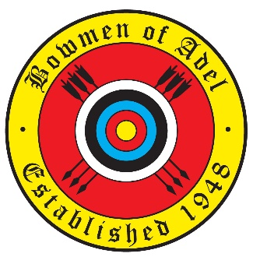
Long Western (adults)
Shorter “Western-family” rounds for juniors (and adults) by entry
(The tournament is not record status)
September 5th 2021
At | Our tournament is supported by
Adel War Memorial Sport And Social Club
Church Lane | 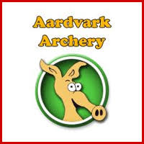
Adel
Leeds LS16 8DE
(Directions available on request)
Judge in Charge – Louise Smith
Lady paramount – tba

Sighters at 11am
Light refreshments available throughout
Entry Fee: Seniors £9 Juniors £5

COVID
- The organisers will follow the guidelines relating to COVID as published by Archery GB that are in effect at the time of the tournament
- Mask wearing is optional outdoors. Masks must be worn indoors
- Hand sanitising facilities will be provided
- Archers may be required to share a boss. If you would be happier sharing only with members of your club, please let the organisers know.
- Refunds will be available if an entrant has to withdraw because of a positive test or requirement to self-isolate.
- Please answer to yourself the following questions.
  - Do you have a high temperature?
  - Do you have a new, continuous cough?
  - Do you have a loss of, or change to, your sense of smell or taste?
  - Are you in a household or bubble with someone who has tested positive for Covid-19 in the past 14 days?
  - Do you have any other Covid symptoms?
  - Has the NHS Covid app advised you to self-isolate?
- If the answer to any of these questions is YES, then you should not attend the competitions.

Awards

Seniors – trophies are awarded for the Long Western only. Adults may shoot a shorter round if they wish, and should indicate this in writing (stating which one!)
Compound, Longbow, Recurve | 1st Lady & 1st Gent | trophy and medal | 2nd / 3rd Lady / Gent | Medal only
Juniors – Western (And shorter rounds as per entries)
Medals are available for each round and age group. Trophies are awarded to the highest scoring junior gent and lady for each bow type (R/C/L), regardless of round shot. Juniors who enter the Long Western will be classed as adults.

Teams - Highest Aggregate Scores (Trophy and individual medals)
Recurve | 4 archers with at least one lady or junior
Longbow | any three archers
Compound | any three archers
Family | members of one family covering at least 2 generations -
Jack & Jill | any couple (of long standing)

Would previous trophy holders remember to return them, cleaned, on or before the day of the tournament.
We are still missing the original Lady Recurve and Recurve Team trophies from this tournament. If you know where they are please let us know.

The results of the tournament will be published on the club website, and passed to the YAA for their website. If you wish your name not to be shown in the published results, please indicate this on the entry form. The Bowmen of Adel will retain full results in its archive

The Bowmen of Adel will retain the contact details of all trophy winners for one year after the tournament. They will be used solely to arrange for the return of trophies.

Catering – Light refreshments will be available throughout the day.
Sadly, our usual bacon butties and cooked lunch will not be available

Archer | AGB No. | Club | Bow style | Junior age group (if applicable) | Please indicate here if you wish your name to be blanked out in published results |  | Do you have a disability?  Y/N (If yes, please give details on  the back of this sheet) | Round  (Blank for  Long Western) | Total fee
Contact email or telephone  (In case of cancellation) |  |  |  |  |  | Total fees
Completed entry forms to:  Nick Beeson  5, Alexandra Place  Ilkley, W Yorks. LS29 9ES | Cheques payable to: Bowmen of Adel | Email entries accepted, to  tournaments@bowmenofadel.co.uk  with payment by electronic transfer | If you wish to pay by electronic transfer please pay :
 |  |  | A/c: Bowmen of Adel A/c no:. 01101528, Sort Code 53-70-00
 |  |  | Please put “EOS21” and your initials or name in the reference field

